***“TO GET THE CONTRACT,***

***MAKE THE CONTACT”***

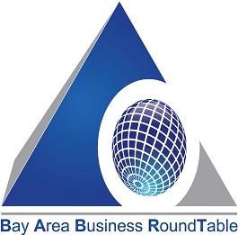

xffdf

**Expected Buyers & Experts from:**

* **State of California Agencies:**
  + **General Services Agency**

**(Co-Sponsor)**

* + **Office of Traffic Safety**
  + **Highway Patrol**
  + **Department of Corrections**
  + **CAL Fire**
  + **CAL Recycle**
  + **Consumer Affairs**
  + **DOT**
  + **California Department of Insurance**
* **U.S. General Services Administration**
* **Alameda County GSA**
* **AC Transit**
* **City of Oakland**
* **Port of Oakland**
* **City of San Leandro**
* **EBMUD**
* **PG&E**
* **BART**

**BUSINESS EXPO WORKSHOP**

With a focus on small, local, and emerging contractors, vendors, and consultants, companies will have a chance to connect with other agencies that have open requisitions as well as present their upcoming contract opportunities

**Pre-Register**

**rttcadmin@rttc.us**

**(510) 568-6302**

**(510) 568-6304**

**Please Provide NAICS & UNSPSC Codes when registering**