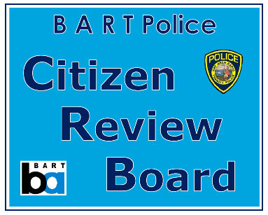

Help provide

citizen oversight of the BART Police Department.

APPLY TODAY!

Position: BART Police Citizen Review Board Member

About the Position
The District is currently accepting applications for membership on the BART Police Citizen Review Board (BPCRB). This appointment will be made by Elizabeth Ames, Director, District 6.
As a volunteer of the BPCRB, members work to increase the public's confidence in BART's policing services by:
- Reviewing, recommending and monitoring the implementation of changes to police policies,
procedures and practices
- Receiving citizen allegations of on-duty police misconduct
- Advising Board of Directors, General Manager, Independent Police Auditor and Police Chief
- Participating in recommending appropriate disciplinary action
- Meeting periodically with representatives of the BART Police associations
- Participating in community outreach

Member Qualifications:
- Resident of Alameda County within District 6
- Fair minded and objective
- Demonstrated commitment to community service
- Not currently employed in a law enforcement capacity, either sworn or non-sworn
- Not a relative of current or former BART Police Department personnel
- No felony convictions

Duration of Service:
All appointments to the BPCRB are for a term of 2 years and there are no term limits.
NOTE: The term of the current seat representing District 6 will expire on June 30, 2021.

How to Apply
To learn more about the BPCRB and/or how to apply for appointment, visit our website at:
https://www.bart.gov/about/bod/advisory/crb.

Please send an email to CitizenReviewBoard@bart.gov or call (510) 464-6089 with any questions.

Application period closes on May 28, 2021.

