San Francisco Bay Area Rapid Transit District
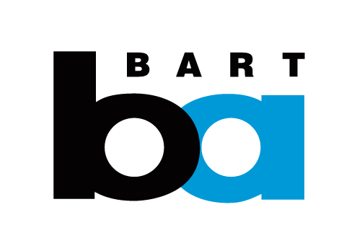
Now Hiring For
Electricians
Starting pay rate is Step 1: $32.92/Hourly
Multiple positions available
Ride BART to a satisfying career that lets you BOTH 1) make a difference to Bay Area residents, and 2) enjoy excellent pay, benefits, and stability. BART is looking for people who like to be challenged, work in a fast paced environment, and have a passion for connecting over 400,000 daily riders to work, school and other places they need to go. BART offers a competitive salary, comprehensive health and medical benefits, paid time off, plus CALPERS retirement in the future.
Minimum Qualifications
Education: Completion of an apprenticeship program in the electrical trade.
Experience: One (1) year (full-time equivalent) verifiable journey level experience in the
installation, maintenance or repair of varied electrical systems and equipment.

Note: Experience with high voltages and industrial or plant equipment is desirable.
Other Requirement: Must possess a valid California Class "B" commercial driver's license and have a satisfactory driving record. Must be physically capable of working in confining work spaces; be willing to work occasional emergency overtime. must be able to walk long distances over various terrain including, but not limited to, uneven, wet, or inclined ground; must be able to climb stairs and ladders to a height of 90 feet; must be able to lift up to 100 pounds to waist level; must be able to work overhead with hand and power tools; must wear respirator.

To apply online go to www.bart.gov/jobs

Equal Employment Opportunity

The San Francisco Bay Area Rapid Transit District is an equal opportunity employer. Applicants shall not be discriminated against because of race, color, sex, sexual orientation, gender identity, age, religion, national origin, disability, ancestry, marital status, veteran status, medical condition (cancer-related), genetic information or any protected category prohibited by local, state or federal laws. The BART Human Resources Department will make reasonable efforts in the examination process to accommodate persons with disabilities or for religious reasons. Please advise the Human Resources Department of any special needs in advance of the examination by calling (510) 464-6112.

Qualified veterans may be eligible to obtain additional veteran's credit in the selection process for this recruitment (effective Jan. 1, 2013). To obtain the credit, veteran's must attach to the application a DD214 discharge document or proof of disability and complete/submit the Veteran's Preference Application no later than the closing date of the posting. For more information about this credit please go to the Veteran's Preference Policy and Application link at www.bart.gov/jobs.

